Tela de exibição de todos os fornecedores

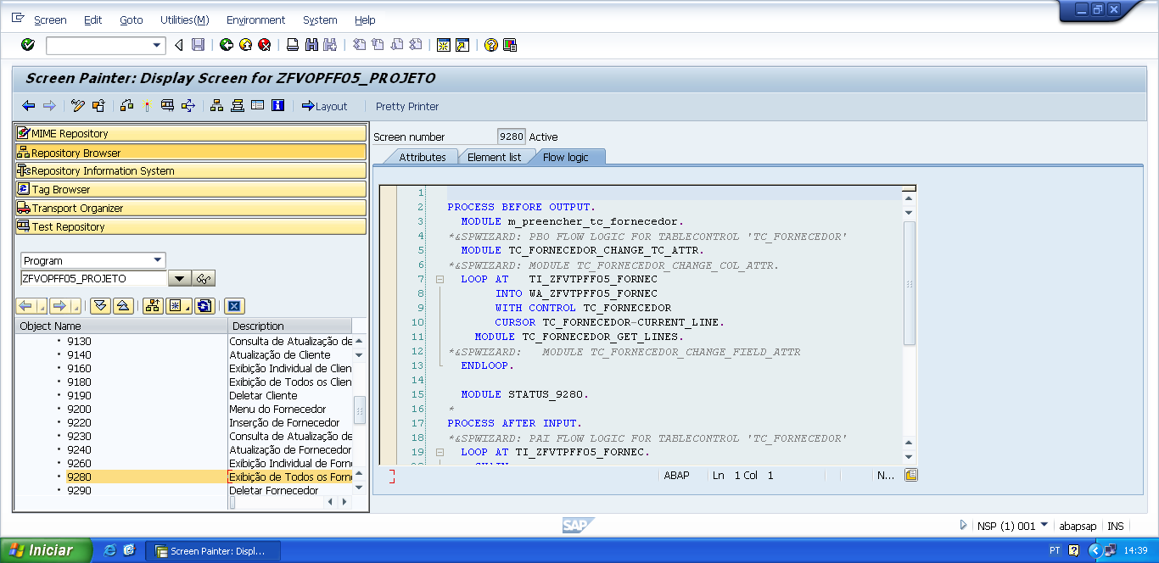

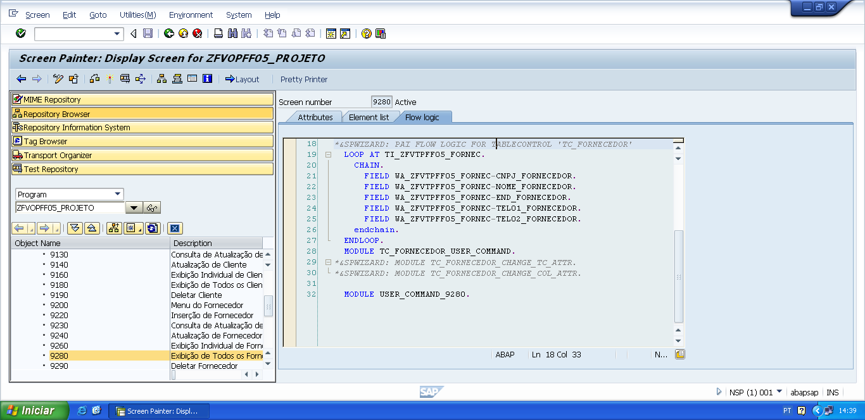

PROCESS BEFORE OUTPUT.  
  MODULE m_preencher_tc_fornecedor.  
*&SPWIZARD: PBO FLOW LOGIC FOR TABLECONTROL 'TC_FORNECEDOR'  
  MODULE TC_FORNECEDOR_CHANGE_TC_ATTR.  
*&SPWIZARD: MODULE TC_FORNECEDOR_CHANGE_COL_ATTR.  
  LOOP AT   TI_ZFVTPFF05_FORNEC  
       INTO WA_ZFVTPFF05_FORNEC  
       WITH CONTROL TC_FORNECEDOR  
       CURSOR TC_FORNECEDOR-CURRENT_LINE.  
    MODULE TC_FORNECEDOR_GET_LINES.  
*&SPWIZARD:   MODULE TC_FORNECEDOR_CHANGE_FIELD_ATTR  
  ENDLOOP.  
  
  MODULE STATUS_9280.

*&---------------------------------------------------------------------*  
*&      Module  STATUS_9280  OUTPUT  
*&---------------------------------------------------------------------*  
*       text  
*----------------------------------------------------------------------*  
MODULE status_9280 OUTPUT.  
  SET PF-STATUS 'STATUS9280'.  
  SET TITLEBAR 'TITULO9280'.  
  
ENDMODULE.                 " STATUS_9280  OUTPUT

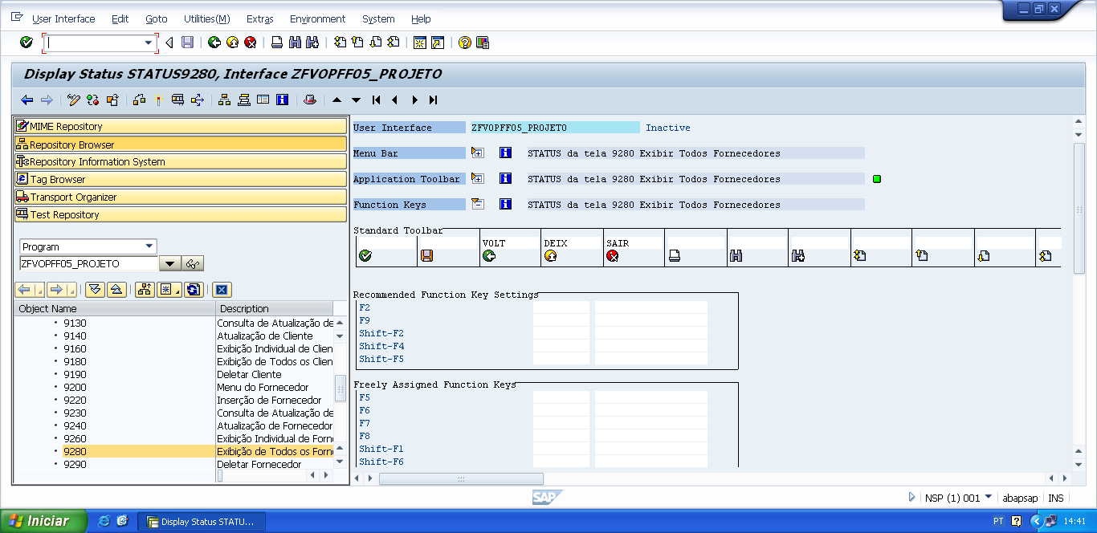

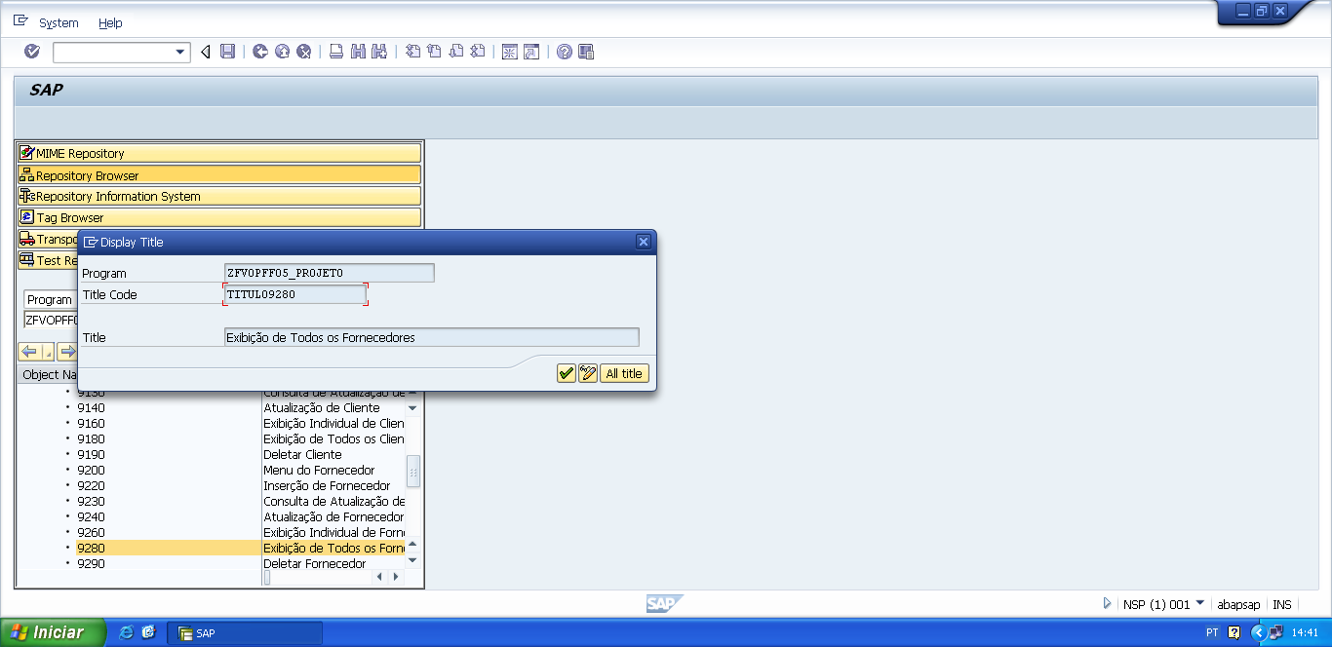

*&---------------------------------------------------------------------*  
*&      Module  M_PREENCHER_TC_FORNECEDOR  OUTPUT  
*&---------------------------------------------------------------------*  
*       text  
*----------------------------------------------------------------------*  
MODULE m_preencher_tc_fornecedor OUTPUT.  
  
  PERFORM f_preencher_tc_fornecedor.  
  
ENDMODULE.                 " M_PREENCHER_TC_FORNECEDOR  OUTPUT

*&---------------------------------------------------------------------*  
*&      Form  F_PREENCHER_TC_FORNECEDOR  
*&---------------------------------------------------------------------*  
*Esse FORM preenche os dados que estão na tabela transparente de  
* fornecedor para a tabela interna do programa referente á fornecedor.  
*----------------------------------------------------------------------*  
*  -->  p1        text  
*  <--  p2        text  
*----------------------------------------------------------------------*  
FORM f_preencher_tc_fornecedor .  
  
  SELECT cnpj_fornecedor  
         nome_fornecedor  
         end_fornecedor  
         tel01_fornecedor  
         tel02_fornecedor  
    FROM zfvtpff05_fornec  
    INTO TABLE ti_zfvtpff05_fornec.  
  
  IF sy-subrc IS INITIAL.  
  
    SORT ti_zfvtpff05_fornec BY cnpj_fornecedor.  
  
  ELSE.  
  
    MESSAGE e001(zfvclpff05).  
  
  ENDIF.  
  
ENDFORM.                    " F_PREENCHER_TC_FORNECEDOR

PROCESS AFTER INPUT.  
*&SPWIZARD: PAI FLOW LOGIC FOR TABLECONTROL 'TC_FORNECEDOR'  
  LOOP AT TI_ZFVTPFF05_FORNEC.  
    CHAIN.  
      FIELD WA_ZFVTPFF05_FORNEC-CNPJ_FORNECEDOR.  
      FIELD WA_ZFVTPFF05_FORNEC-NOME_FORNECEDOR.  
      FIELD WA_ZFVTPFF05_FORNEC-END_FORNECEDOR.  
      FIELD WA_ZFVTPFF05_FORNEC-TEL01_FORNECEDOR.  
      FIELD WA_ZFVTPFF05_FORNEC-TEL02_FORNECEDOR.  
    endchain.  
  ENDLOOP.  
  MODULE TC_FORNECEDOR_USER_COMMAND.  
*&SPWIZARD: MODULE TC_FORNECEDOR_CHANGE_TC_ATTR.  
*&SPWIZARD: MODULE TC_FORNECEDOR_CHANGE_COL_ATTR.  
  
  MODULE USER_COMMAND_9280.

*&---------------------------------------------------------------------*  
*&      Module  USER_COMMAND_9280  INPUT  
*&---------------------------------------------------------------------*  
*       text  
*----------------------------------------------------------------------*  
MODULE user_command_9280 INPUT.  
  
  v_okcode = sy-ucomm.  
  
  CASE v_okcode.  
    WHEN 'VOLT'.  
      PERFORM f_voltar.  
    WHEN 'DEIX'.  
      PERFORM f_deixar.  
    WHEN 'SAIR'.  
      PERFORM f_sair.  
  ENDCASE.  
  
  CLEAR v_okcode.  
ENDMODULE.                 " USER_COMMAND_9280  INPUT

*&---------------------------------------------------------------------*  
*&      Form  F_VOLTAR  
*&---------------------------------------------------------------------*  
* FORM de voltar, serve para voltar automaticamente para a tela  
*anterior da tela atual.  
*----------------------------------------------------------------------*  
*  -->  p1        text  
*  <--  p2        text  
*----------------------------------------------------------------------*  
FORM f_voltar.  
  
*Volte para á tela 9000 (Tela Principal)  
*ou  
**CALL SCREEN '9000'.**  
  PERFORM f_limpar_variaveis.  
  SET SCREEN 0.  
  LEAVE SCREEN.  
  
  
ENDFORM.                    " F_VOLTAR  
  
*&---------------------------------------------------------------------*  
*&      Form  F_DEIXAR  
*&---------------------------------------------------------------------*  
*       text  
*----------------------------------------------------------------------*  
*  -->  p1        text  
*  <--  p2        text  
*----------------------------------------------------------------------*  
FORM f_deixar .  
  
  LEAVE LIST-PROCESSING.  
  
ENDFORM.                    " F_DEIXAR  
  
*&---------------------------------------------------------------------*  
*&      Form  F_SAIR  
*&---------------------------------------------------------------------*  
*       text  
*----------------------------------------------------------------------*  
*  -->  p1        text  
*  <--  p2        text  
*----------------------------------------------------------------------*  
FORM f_sair.  
  
  LEAVE LIST-PROCESSING.  
  
ENDFORM.                    " F_SAIR